./

Learning Report – Automotive Systems and Overview

Course Code: <CODE>



Version Number:

Team Members :

Team No:

Module: Model Based System Engineering

|  |  |  |  |  |  |
| --- | --- | --- | --- | --- | --- |
| **Ver. Rel. No.** | **Release Date** | **Prepared. By** | **Reviewed By** | **Approved By** | **Remarks/Revision Details** |
| 1 | 19-03-2021 | Kopparapu Jyothi Swaroopa Rani |  |  |  |

**Document History**

# 

Contents

**INTRODUCTION** 4

**RESEARCH** 4

**FEATURES** 4

**SWOT ANALYSIS** 5

**REQUIREMENTS** 5

**DESIGN AND IMPLEMENTION…………………………………………………………………………………………………………………………………..**

**TEST PLAN**

1.INTRODUCTION:

1.1Wiper Control System:

In today’s automotive industry, the issue of driver safety and comfort is of great importance. An automatic windshield wiper system is of great aid in such cases. It betters the driving experience and improvises the safety factor of a vehicle by converting the manual windshield wiper system into an automatic system. By taking care of the attentions drivers would have to devote to control a manual system, an automatic wiper system helps them to concentrate more on driving safely. Although, few automated windshield wiper systems are available in the automotive market, they are very costly and not very effective. This project a cost effective and high performance automatic windshield wiper system developed using an Arduino Uno microcontroller and a rain intensity detection sensor. The system was programmed to use fuzzy logic to manipulate the analog data collected from the sensor, and the microcontroller controlled the wiper motor using pulse width modulation (PWM). The use of fuzzy logic allows the system to be easily reconfigurable. Such feature can be utilized to design different wiper system for different vehicles and weather conditions without any hardware modification.

1.2. Research And Literature Survey:

For about twenty years, a significant amount of researches have been conducted to automatize the windshield wiper systems. Primitive ideas of using ultrasonic vibrations to remove the raindrops from the windshield or using special coating that prevent raindrops to form in the windshield has been proven ineffective as drivers found those systems annoying and disturbing. Among other considered ideas, the idea of using optical rain sensor has proven to be somewhat effective. For this wiper system, an optical rain sensor was used, which detected the change in the reflection of light projected by another source to determine the presence of water in the windshield. This system has been produced by TRW Inc. and has been used in recent Cadillac cars manufactured by General Motors (GM). However the method has also been proven less effective for certain circumstances. The next section addresses the disadvantages of this system along with other considered systems. Although many automobile companies didn’t have automatic windshield wipers available for their marketed vehicles before, many companies are currently manufacturing vehicles with automatic windshield wiper system. Renowned automotive companies such as Toyota Motor Corporation and Honda Motor Companies have launched their new vehicles equipped with rain-sensing wipers. Additionally, other companies, for example Ford Motor Company and Volkswagen AG, are also bringing in rain-sensing wipers into the market. Specific information about the wiper system of those vehicles is not available, as those vehicles are not available in the market yet.

1.3 Inputs:

* We’re using Rotary switch for wiper control System.
* LO: If we press LO, then the wiper will wipe for low intensity of rain drops with low speed.
* HI: If we press HI, then the wiper will wipe for high intensity of rain drops with high speed.
* 1X: If we press 1X, then the wiper will wipe for one time forward and backward.
* Off: If we press Off, then the wiper will Off.
* Input Voltage: 3.3V
* Input Current: 5A

1.4 SWOT ANALYSIS:

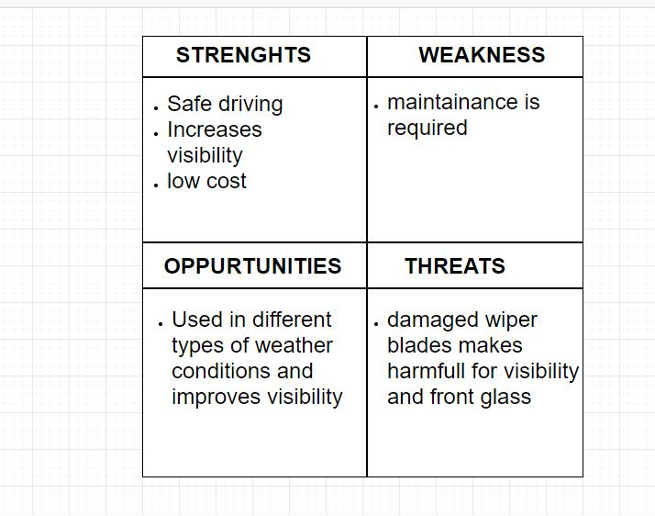

Fig 1.4.1 Swot Analysis

1.5 REQUIREMENTS:

1.5.1 High Level Requirements:

|  |  |
| --- | --- |
| **Before** | **After** |
| Front Glass Wiper | Rear Glass Wiper |
| Front Glass Wiper | Rear Glass Wiper |

1.5.2 Low Level Requirements:

|  |  |
| --- | --- |
| **Before** | **After** |
| Low Speed Wiper | Low Speed Wiper  Wiper arm  Wiper linkage  Wiper motor  Wiper Blade |
| High Speed Wiper | High Speed Wiper  Wiper arm  Wiper linkage  Wiper motor  Wiper Blade |
| Mist Wiper | Mist Wiper  Wiper arm  Wiper linkage  Wiper motor  Wiper Blade |

1.5.3 Components:

* Arduino Uno (Atmega 328)
* Windshield Wiper motor
* Rain Sensor
* Power Supply Module (DSN2596)
* Rotary Switch (RW200)

2.DESIGN AND IMPLEMENTATION:

2.1 WORKING:

Whenever rain drops fall on the Rain intensity detection sensor, it detects and receive analog data and sends to the controller. On other side, vehicle battery (11v to 13v) provides power to the power supply module(3.3v) and it sends to controller. From the controller the signals are sent to the wiper motor and then the wiper wipes based on the intensity of rain drops.

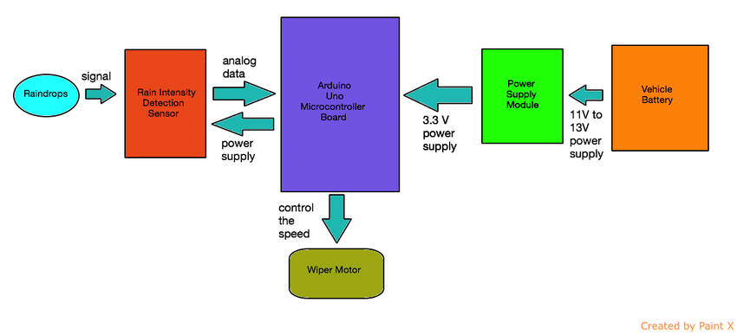

Fig 2.1.1 Block Diagram of wiper control system

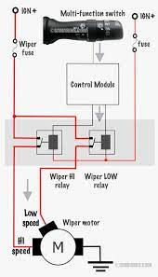

Fig 2.1.2 Internal Explanation of Wiper Control System

2.2 FLOW CHART:

Wiper starts wiping based on above condition

High Duty Cycle

PWM

If High Speed Rain?

If low speed rain?

If Mist?

Low Duty Cycle PWM

2.3DESIGN:

2.3.1 High Level Implementation:

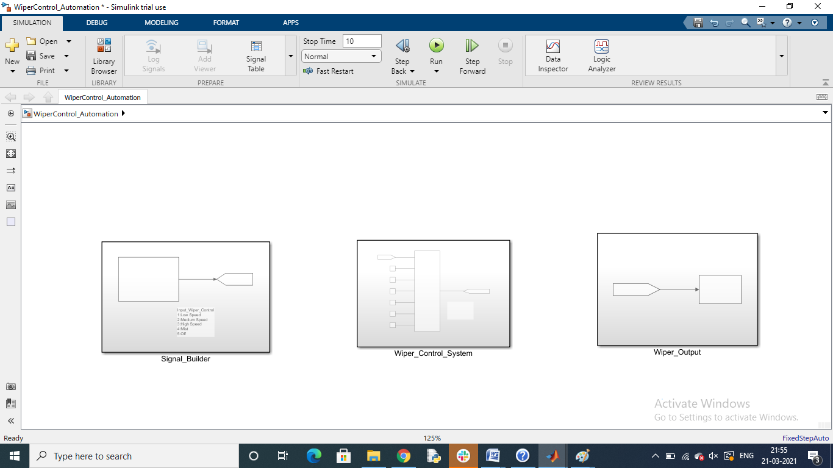

Fig 2.3.1.1 High level implementation of Wiper Control System

2.3.2 Low Level Implementation:

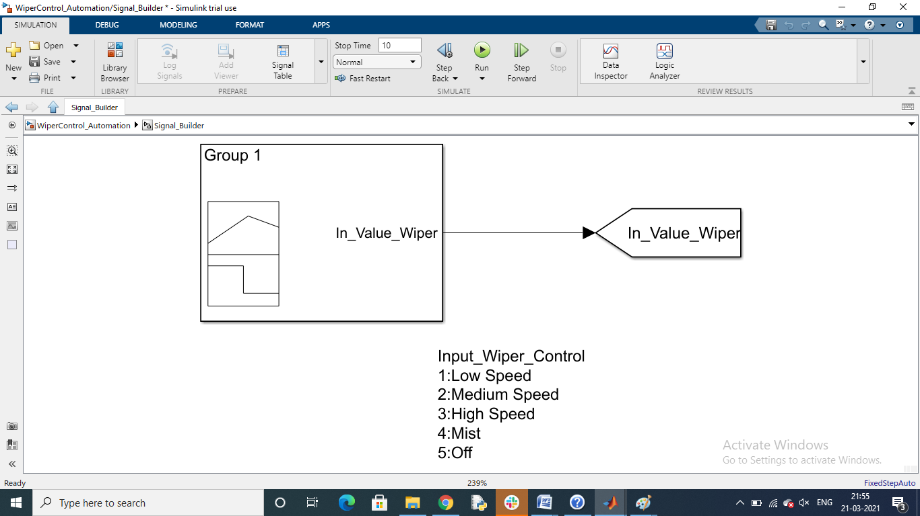

Fig 2.3.2.1 Low Level Implementation (Signal Builder)

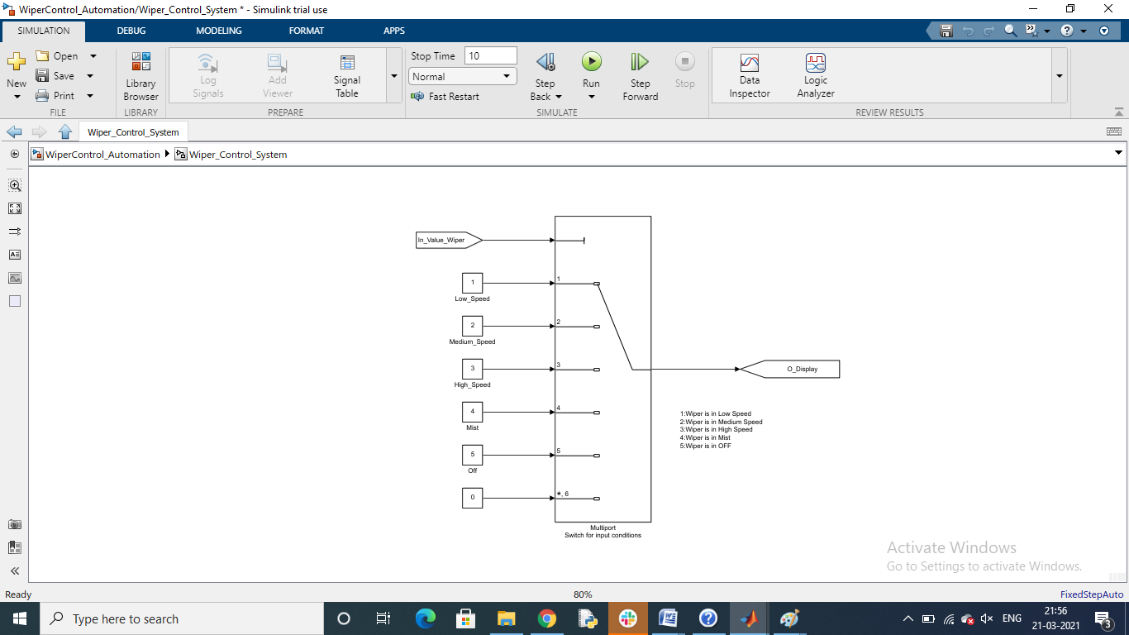

Fig 2.3.2.2 Low Level Implementation (Wiper Control System)

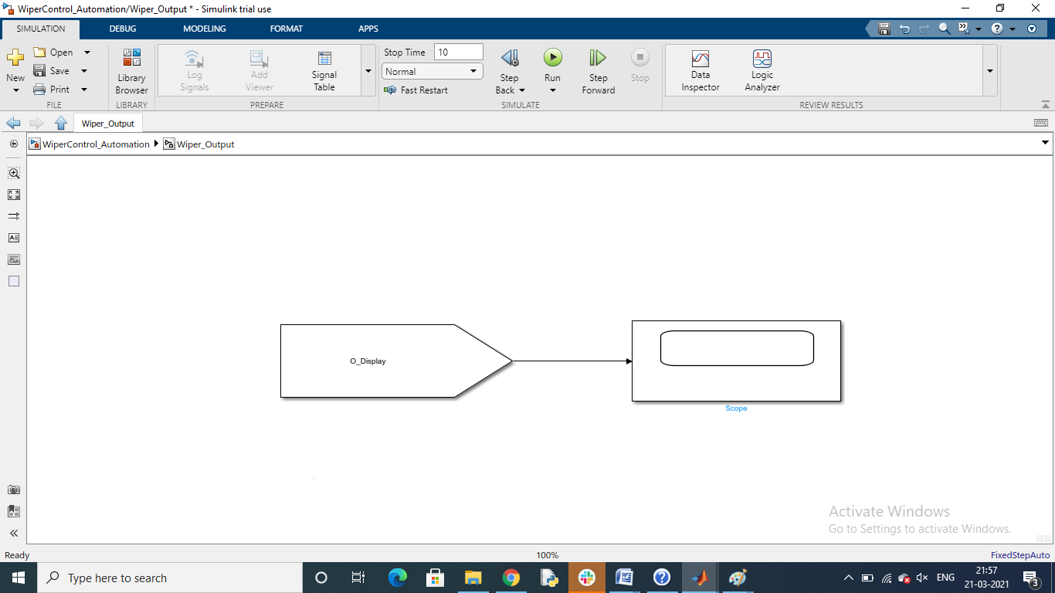

Fig 2.3.2.2 Low Level Implementation (Output)

2.4 DESCRIPTION:

2.4.1 Rain Sensor:

Raindrop Sensor is a tool used for sensing rain. It consists of two modules, a **rain board** that detects the rain and a **control module**, which compares the analog value, and converts it to a digital value. The raindrop sensors can be used in the automobile sector to control the windshield wipers automatically.

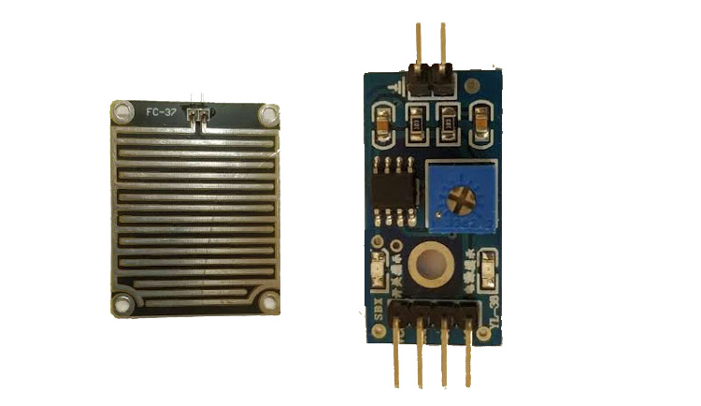

Fig 2.4.1.1 Rain Sensor

|  |  |  |
| --- | --- | --- |
| **S.No:** | **Name** | **Function** |
| 1 | VCC | Connects supply voltage- 5V |
| 2 | GND | Connected to ground |
| 3 | D0 | Digital pin to get digital output |
| 4 | A0 | Analog pin to get analog output |

Table 2.4.1.2 Rain Sensor Pin Configuration

2.4.1.1 Features:

1. Working voltage 5V

2. Output format: Digital switching output (0 and 1), and analog voltage output AO

3. Potentiometer adjust the sensitivity

4. Uses a wide voltage LM393 comparator

5. Comparator output signal clean waveform is good, driving ability, over 15mA

6. Anti-oxidation, anti-conductivity, with long use time

7. With bolt holes for easy installation

8. Small board PCB size: 3.2cm x 1.4cm

2.4.1.2 Sensor Data (Inputs and Outputs):

|  |  |
| --- | --- |
| Operating voltage | 12 VDC ±10 % |
| Average power consumption | 0.30 W at 12 V |
| Maximum power consumption with sensor plate heating on | 3.12 W at 12 V 1) |
| Analog output | 1 to 3 V (wet to dry) |
| Operating temperature | -15 … +55 °C (+5 … +131 °F) |

2.4.2 Arduino UNO (Control device):

A microcontroller was used rather than using a footprint mini-computer like Raspberry pi as the control devise between the sensor and the wiper motor. The microcontroller used was Arduino Uno, a microcontroller board built based on the ATmega328. It has 14 digital input/output pins (of which 6 can be used as PWM outputs), 6 analog inputs, and a 16 MHz ceramic resonator. Arduino Uno is preferred to Raspberry pi because higher functionality, security, expandability and cost effective features. As the developed system requires a better hardware support base, rather than computer-like features, Arduino is a better choice in terms of functionality. Besides, the hardware nodes of an Arduino Uno is more secured than that of Raspberry pi, as in order to change any functionality of the nodes an intruder needs to know the software codes, whereas for Raspberry pi he only need an external SD card. Moreover, Arduino Uno is open source whereas Raspberry pi is closed source. That’s why, an Arduino compatible board is less expensive. Moreover, Arduino Uno supports a greater range of modules, thus a wide choice of sensors can be used.



Fig 2.4.2.1 Arduino Uno

2.4.3 Power supply module:

The voltage range of automotive vehicles range from 11 Volts to 13.5 Volts, and the Arduino can be powered using 3.3 Volts, 5 Volts or 9 Volts. Therefore, a power supply module was used to convert the vehicle voltage to Arduino Uno compatible voltage. The module used was DSN2596. It can take in 3.2V-40V and convert it into 1.25V-35V. The module has a built-in potentiometer to control the output voltage. For this system, 3.3V output voltage was used. This module is very accurate and cost effective ($0.90). The power supply module is shown in Figure below.



Fig 2.4.3.1 Power Supply Module

2.4.4 Windshield Wiper Motor:

For this system, the built-in electric wiper motor with permanent magnet of the tested car was used. The built-in motor had four inputs: one for the highest speed movement of the motor (colored blue and red), one for the lowest speed (colored blue and white) and two other inputs for intermediate speeds to provide the speed variations.

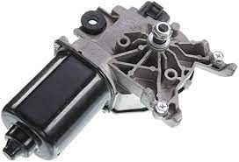

Fig 2.4.4.1 Wind Shield Wiper Motor

2.4.5 Rotary Wiper Control Switch:

The RW200 series **Rotary Wiper** has four **wiper control** positions via a rotating knob: Off, Intermittent, Continuous Low Speed and Continuous High Speed. The device has a washer function that operates the washer pump and **wiper** while the knob is depressed.

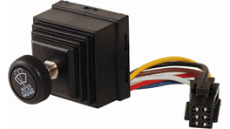

Fig 2.4.5.1 Rotary Switch

**3.TEST PLAN:**

3.1 High-Level:

|  |  |  |  |  |
| --- | --- | --- | --- | --- |
| Test ID | Test Description | Input | Actual Output | Expected Output |
| FW_HL_1 | Enabling front wind shield wiper | Front Wiper should be on | Front Wiper On | Front Wiper On |
| RW_HL_2 | Enabling rear wind shield wiper | Rear Wiper should be on | Rear Wiper On | Rear Wiper On |

3.1.1 High Level Test Plan

3.2 LOW LEVEL:

|  |  |  |  |  |
| --- | --- | --- | --- | --- |
| Test ID | Test Description | Input | Actual Output | Expected Output |
| LS_LL_1 | Enabling Low Speed Wiper | Low Speed Wiper should be On | Low Speed Wiper On | Low Speed Wiper On |
| HS_LL_2 | Enabling High Speed Wiper | High Speed Wiper should be On | High Speed Wiper On | High Speed Wiper On |
| M_LL_3 | Enabling Mist condition Wiper | Mist Condition Wiper should be On | Mist Condition Wiper On | Mist Condition Wiper On |

3.2.1 Low Level Test Plan

**4.REFERENCES:**

[**https://www.ijaiem.org/volume2issue7/IJAIEM-2013-07-29-113.pdf**](https://www.ijaiem.org/volume2issue7/IJAIEM-2013-07-29-113.pdf)

[**https://components101.com/sensors/rain-drop-sensor-module**](https://components101.com/sensors/rain-drop-sensor-module)

[**https://lastminuteengineers.com/rain-sensor-arduino-tutorial/**](https://lastminuteengineers.com/rain-sensor-arduino-tutorial/)

[**https://www.ti.com/solution/wiper-module**](https://www.ti.com/solution/wiper-module)

[**https://www.researchgate.net/figure/Block-diagram-of-the-windshield-wiper-system_fig3_275643772**](https://www.researchgate.net/figure/Block-diagram-of-the-windshield-wiper-system_fig3_275643772)

[**https://www.researchgate.net/publication/275643772_DESIGN_AND_IMPLEMENTATION_OF_A_RECONFIGURABLE_AUTOMATIC_RAIN_SENSITIVE_WINDSHIELD_WIPER/link/5543084f0cf24107d3948d8d/download**](https://www.researchgate.net/publication/275643772_DESIGN_AND_IMPLEMENTATION_OF_A_RECONFIGURABLE_AUTOMATIC_RAIN_SENSITIVE_WINDSHIELD_WIPER/link/5543084f0cf24107d3948d8d/download)

[**https://ijaiem.org/volume2issue7/IJAIEM-2013-07-29-113.pdf**](https://ijaiem.org/volume2issue7/IJAIEM-2013-07-29-113.pdf)

[**https://source.z2data.com/2017/2/2/11/50/11/820/282901374/r30ca0007ej0450-automotive.pdf**](https://source.z2data.com/2017/2/2/11/50/11/820/282901374/r30ca0007ej0450-automotive.pdf)